

EE464

STATIC POWER CONVERSION II

HARDWARE PROJECT REPORT

Mehmet Eralp KÖSE 2031094

Muhammet Emin CİNALİOĞLU 2030427

Celal KAVLAK 2030955

Due: 08.06.2018

TABLE OF CONTENTS

INTRODUCTION 3

MAIN OPERATION 4

DESIGN DECISIONS 7

Transformer Design 7

Snubber Design 9

SIMULATION RESULTS 11

COMPONENTS SELECTION 18

TEST RESULTS 21

CONCLUSION 27

REFERENCES 28

# INTRODUCTION

This report includes technical details, test results, performance results and cost analysis of the flyback converter which is constructed by ISWT. To design 12/48 Volts 80W flyback converter, we started with making simulation about the flyback with given specifications. Then we started to design a transformer according to theoretical expressions and simulation results. During transformer design, we gave importance to magnetizing inductance to provide required mode condition. After that, we started to examine suitable components for our flyback configuration. During this process, we select core material, switch, diodes, capacitors etc. Also we decided to use Arduino to provide switching for selected switching component.

During construction of the circuit on the board, we tried to minimize size of the converter also we gave importance to heat flow of the converter. Since due to high frequency of switching, switching component heated up dramatically during operation. When we constructed the flyback on the board, we started to make test for understanding how our converter works under different loads. Due to some problems, we cannot reach full load operation which is 80W output operation. Figure 1 shows the final view of the converter which is constructed by ISWT.

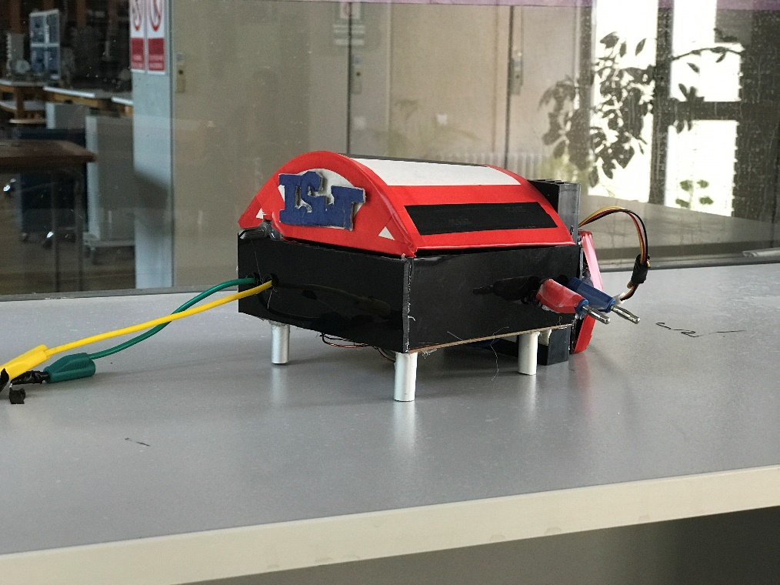

Figure 1:12/48V Flyback Converter which is produced by ISWT

# MAIN OPERATION

In this part, main operation of flyback converter is explained. Figure 2 shows the basic flyback configuration.

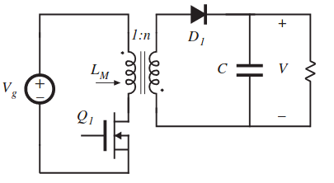

Figure 2: Circuit Schematic of the Flyback Converter

Flyback converters are derived from the buck-boost converter. Operation of flyback converter can be investigated according to two states which are switch ON and switch OFF period.

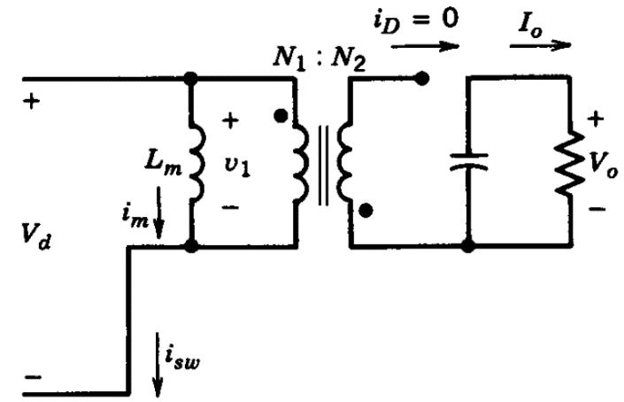

Figure 3: Approximate Circuit Schematic of Flyback during Switch is ON

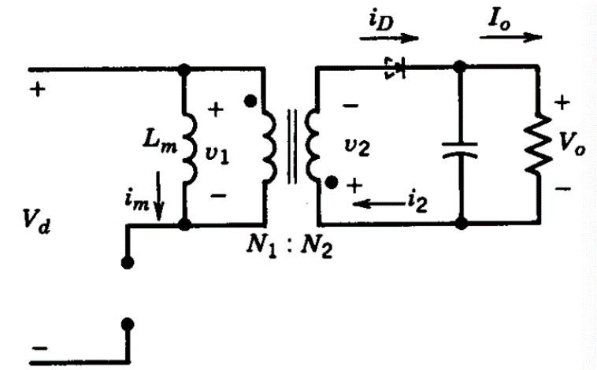

Figure 4: Approximate Circuit Schematic of Flyback during Switch is OFF

Figure 3 shows the circuit schematic of the flyback converter during switch is ON period and Figure 4 shows the circuit schematic of the flyback during switch is OFF period. [2]

When the switch is ON, due to winding polarities, the diode will be reversed biased. The continuous-current-conduction mode in buck-boost converter corresponds to an incomplete demagnetization of the inductor core in the flyback converter. After the switch is turned off and the energy stored in the core causes the current to flow in the secondary winding through the diode.

Figure 5 shows the voltage on the magnetizing branch, core flux and the diode current of the flyback converter.

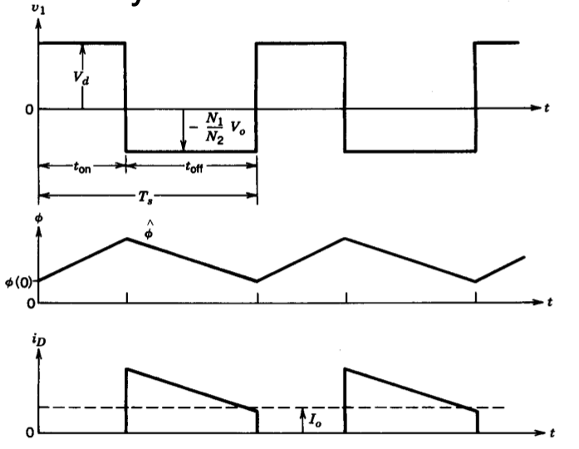

Figure 5: Voltage across the Magnetizing branch, core flux and the diode current

Voltage transfer ratio of the flyback converter can be calculated according to core flux.

and,

Since the periodic characteristic,

Therefore,

MOSFET’s ideally don’t require any current while they are opening. But practically, they needs a few tens of mA to open MOSFET. Because gate to source capacitance of the MOSFET should be charged while opening. Also it should be uncharged while it is closing. On the other hand, this process should be done using isolation between gate driver circuit and gate of the power MOSFET. Also PWM signal should be amplified before connected to gate of the MOSFET.

In order to achieve these two main goals, we decided to use TLP250 opto coupler module. It can provide isolation and it can amplify PWM signal to the required level.

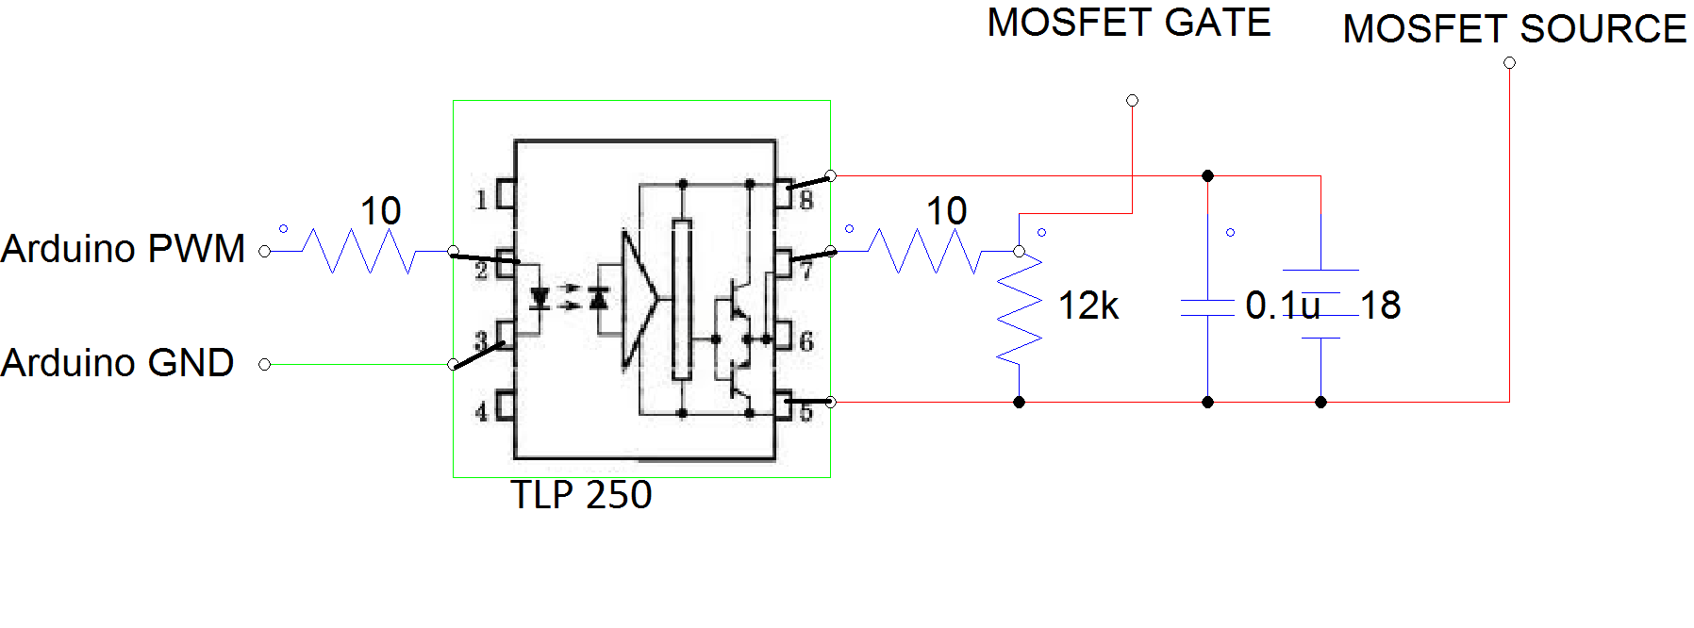

Figure 6: Circuit Schematic of the TLP250 (Gate Driver)

# DESIGN DECISIONS

## Transformer Design

As introductory, a trade-off rises between the core efficiency and core size. A moderate frequency is selected to keep these two parameters reasonable, which is 62500 Hz. ΔIlm is chosen as 6A. Therefore, at 75% duty cycle, primary side inductance should be:

which yields Lm=24 µH.

To select the proper core, it is necessary to investigate the some properties of the core types:

1. Saturation flux density
2. Inductance Factor and
   1. Gap
   2. Dimensions
   3. Equivalent permeability
3. Window area

ETD 39 core with N87 material and 2mm gap can show desired performance. Its corresponding inductance factor is 115 nH[reference of ETD core] :

To check the saturation of the material,

Its saturation flux density is 0.32 T. From the formula

Maximum current carrying capability of the transformer can be calculated. Take B=Bmax=0.32 T. Ae=125 mm2, ℜ=1/AL=8695652, N=14

Imax=24.8 A, which is above current range of magnetizing inductance.

, which is in the current capability range of the transformer.

If the core saturated, either gap would be increased and turn number would be increased by the ratio of square root of gap increase, the size of the core would be increased or frequency is increased. In the first case, the limiting factor is window area. As turn number increases, it gets harder to fit in window area and temperature rise becomes more critical for central layers of cables wound on coil former. Moreover, while we keep magnetizing inductance constant through this operation, leakage inductance increases as turns number increases.

To calculate the N2,

is used. N2 is about 19 turns in ideal case. However, to compensate the voltage drop on switching MOSFET, output diode and copper resistances, turns ratio is increased to 28 in practice.

## Snubber Design

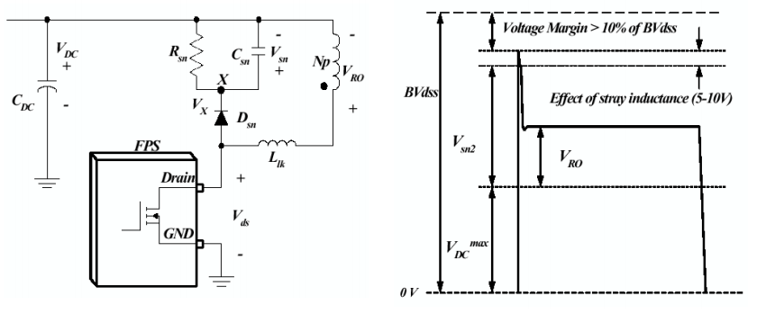

Figure 7: Snubber Design

In the snubber design, the purpose is to keep drain-source voltage of the MOSFET below its rated value. Also, the energy stored in the leakage inductance is dissipated on the snubber in order to avoid transformer from heating up. The rated Vds of the MOSFET is 200V. Vds=Vsn+VDC. Vdc =12 V. Keeping Vsn at 160 V is enough for safe operation of MOSFET and transformer. Rsn is calculated by the formula [1].

1 kΩ is used as snubber resistor.

As snubber capacitor (Csn), 10 µF is used in order to decrease the ripple on the Vsn

Power dissipation on the snubber is

This high amount of dissipation is due to large leakage inductance. In order to achieve desired magnetizing inductance, turns number on gapped transformers should be increased more compared to ungapped ones. Increasing turns results in higher leakage inductance.

# SIMULATION RESULTS

There is an R load in the simulations. 80 W is intended. Therefore;

P=V2/R

P=80W,

V=48 V,

R=28.8V

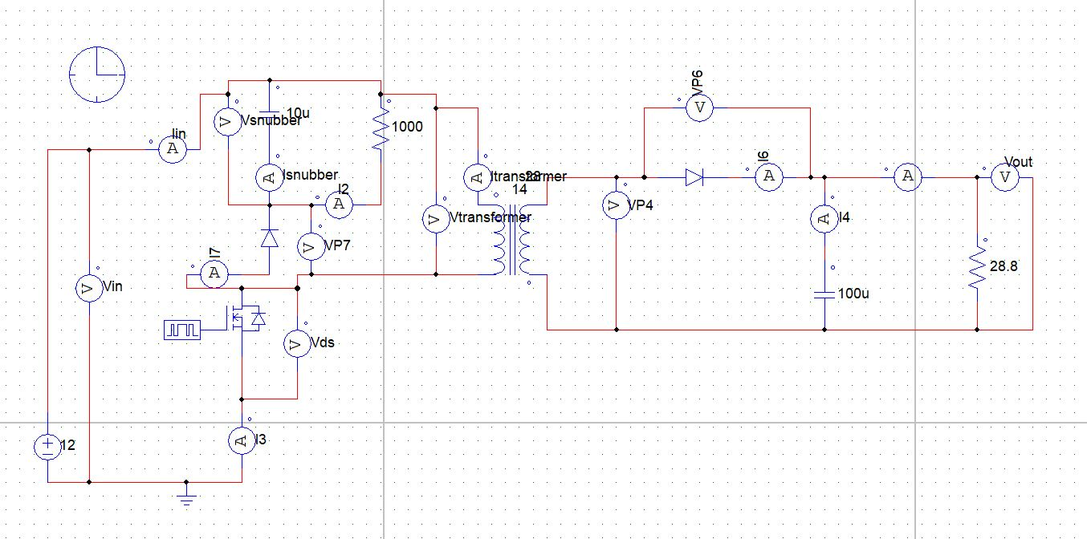

Figure 8: Circuit Schematic for 12V -48V Flyback Converter (Without Gate Driver)

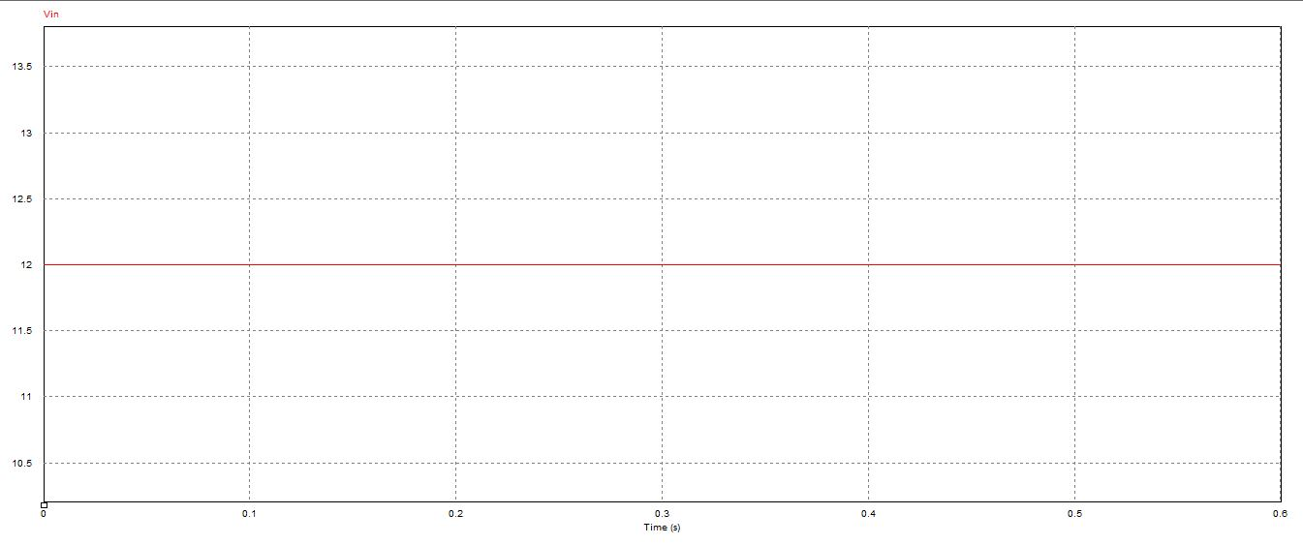

Figure 9: Input Voltage Waveform

In this project 12V input voltage is converted to 48 V output voltage by using Flyback converter and input voltage is 12V as shown in Figure 9.

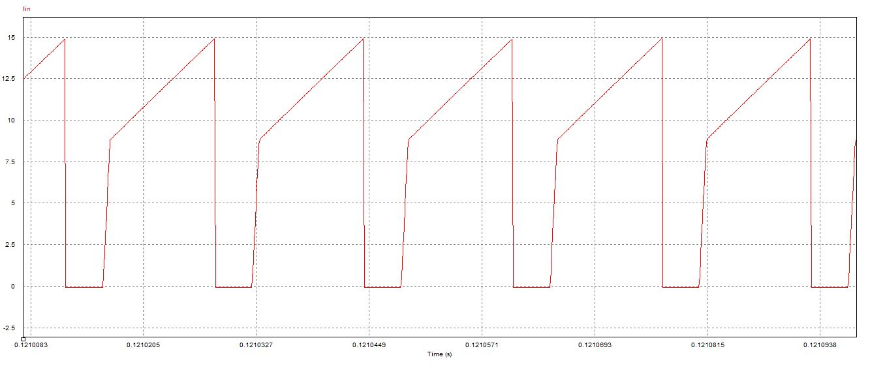

Figure 10: Input Current Waveform

Input waveform is shown in Figure 10. This characteristic is expected. Slope of the voltage depends on Lm and there is not a saturation so Lm characteristic is sharp. In addition, continuous conduction mode is observed. Mean current is nearly 80/12=6.67 V.

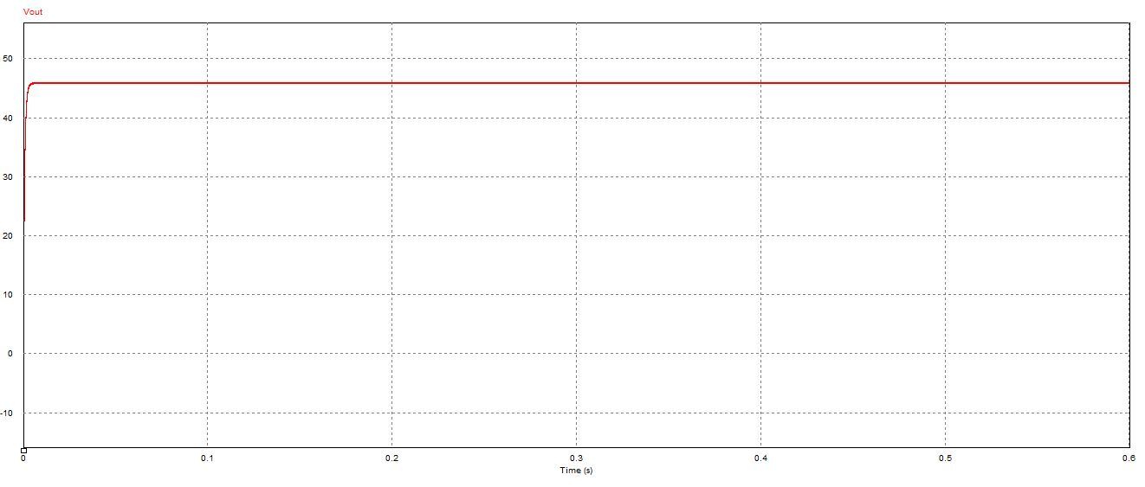

Figure 11: Output Voltage Waveform

Output voltage is nearly 48 V as shown in Figure 11.

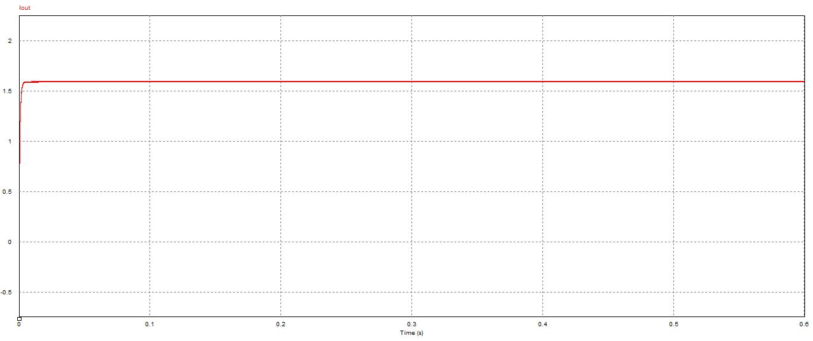

Figure 12: Output Current Waveform

Output current waveform is observed in Figure 12. Mean value is nearly 1.67 V.

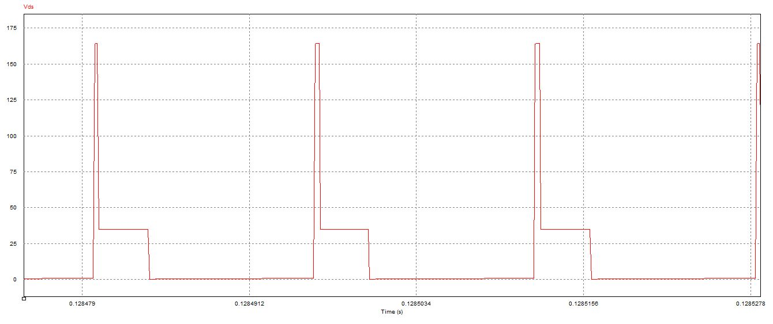

Figure 13: Vds (Drain- Source Voltage) of the MOSFET

Drain to source voltage is shown in Figure 13. Spikes are crucial for MOSFET selection and this peak values are intended to decrease by using snubber. Theoretically, nearly 170 V peak value is observed so at least a MOSFET which has 200 V drain to source value should be selected.

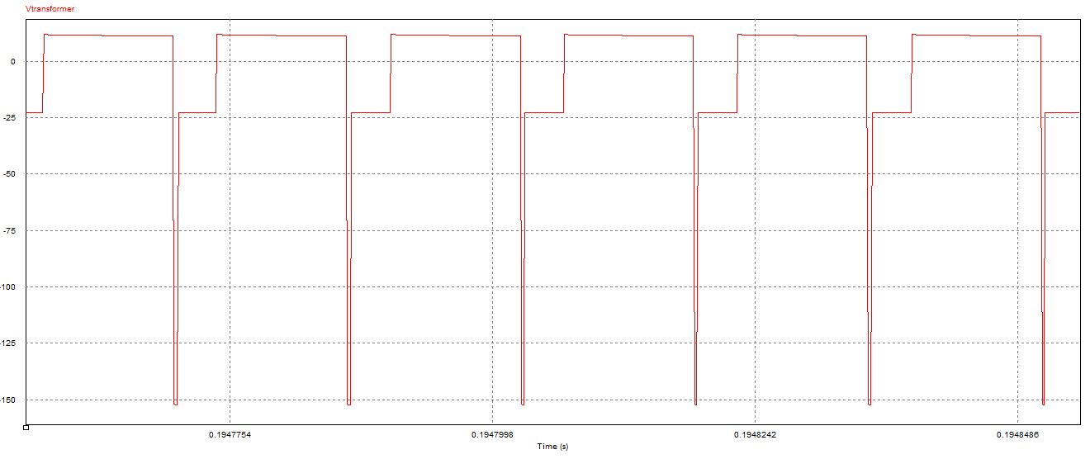

Figure 14: Transformer Voltage Waveform

Transformer voltage characteristic is shown in Figure 14. If the transformer was ideal; that is, if there was not a leakage inductance, negative spikes would not be observed; however, practically this spikes are observed and snubber design has an importance in order to use transformer effectively.

Negative spikes are observed due to the instantaneous current changes at the switching instants.

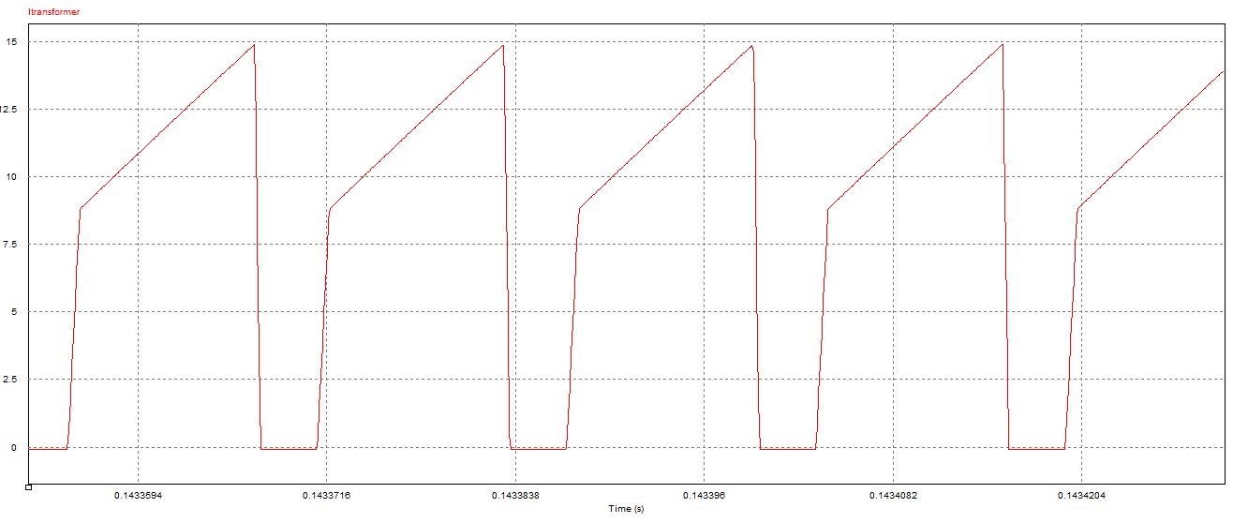

Figure 15: Transformer Current Waveform

Transformer current waveform characteristic is the same as input current characteristic as expected. Lm is an affective factor for the slope of the voltage characteristic. Saturation is not observed.

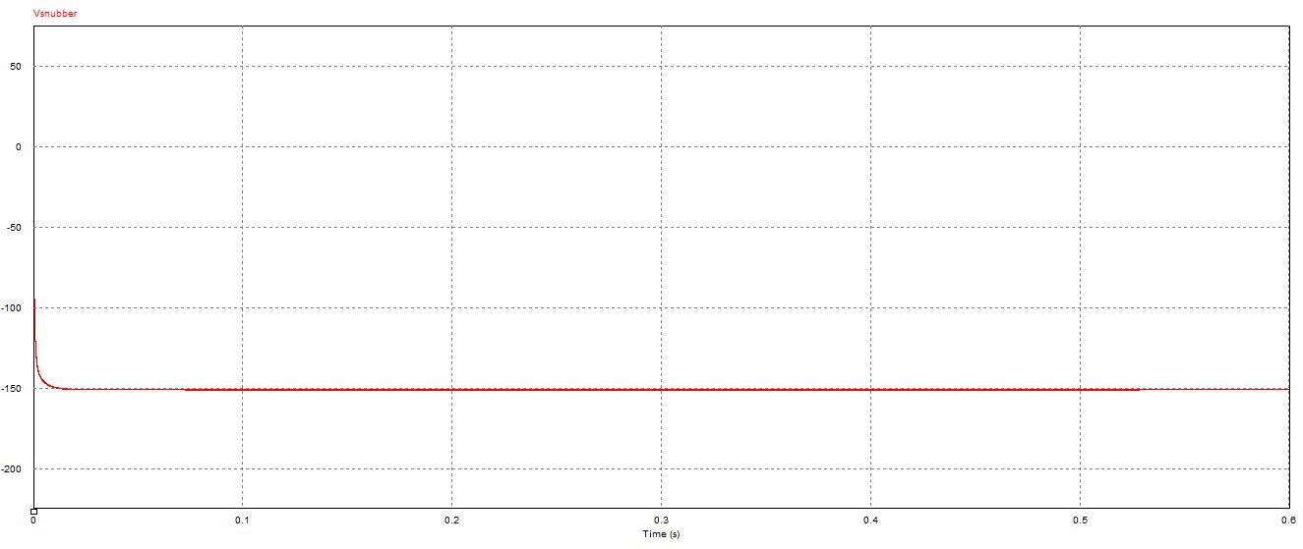

Figure 16: Snubber Resistor Voltage Waveform

Snubber Voltage waveform is observed as shown in Figure 16. Nearly 150 V is kept from the snubber so drain to source voltage of the MOSFET is decreased by using snubber. Snubber design and MOSFET selection have a relation each other. If there was not a snubber, Vds of the MOSFET would be very high and selected MOSFET should be changed.

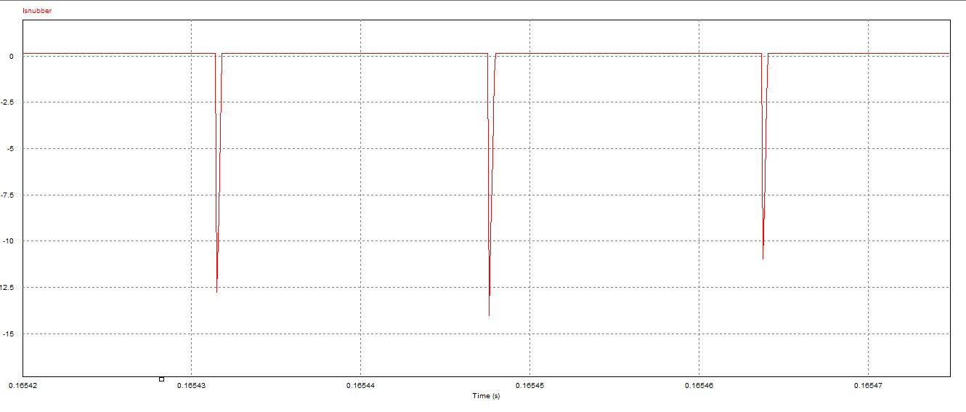

Figure 17: Snubber Resistor Current Waveform

Snubber current is shown in Figure 17. There is negative instant currents at the switching instants due to the leakage inductance.

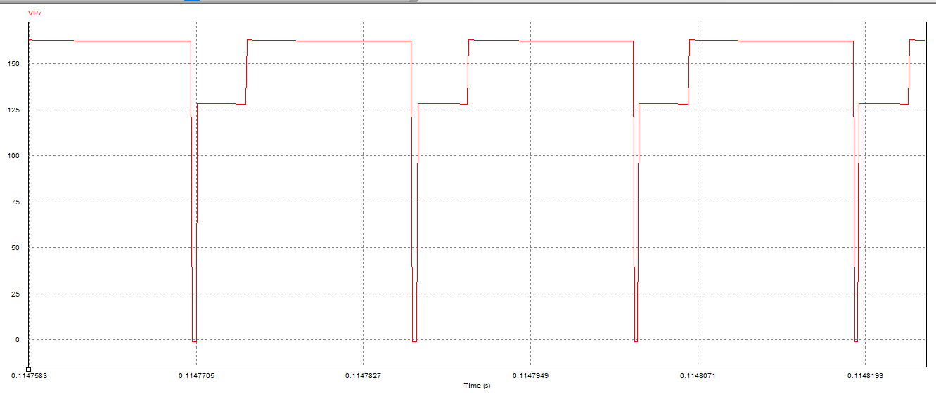

Figure 18: Snubber Diode Voltage Waveform

Snubber diode voltage waveform is shown in Figure 18. As expected, summation of resistor voltage and diode voltage gives transformer voltage. Due to the leakage inductance, spikes are observed at the switching instants. Thanks to snubber, drain- source voltage of the MOSFET is decreased.

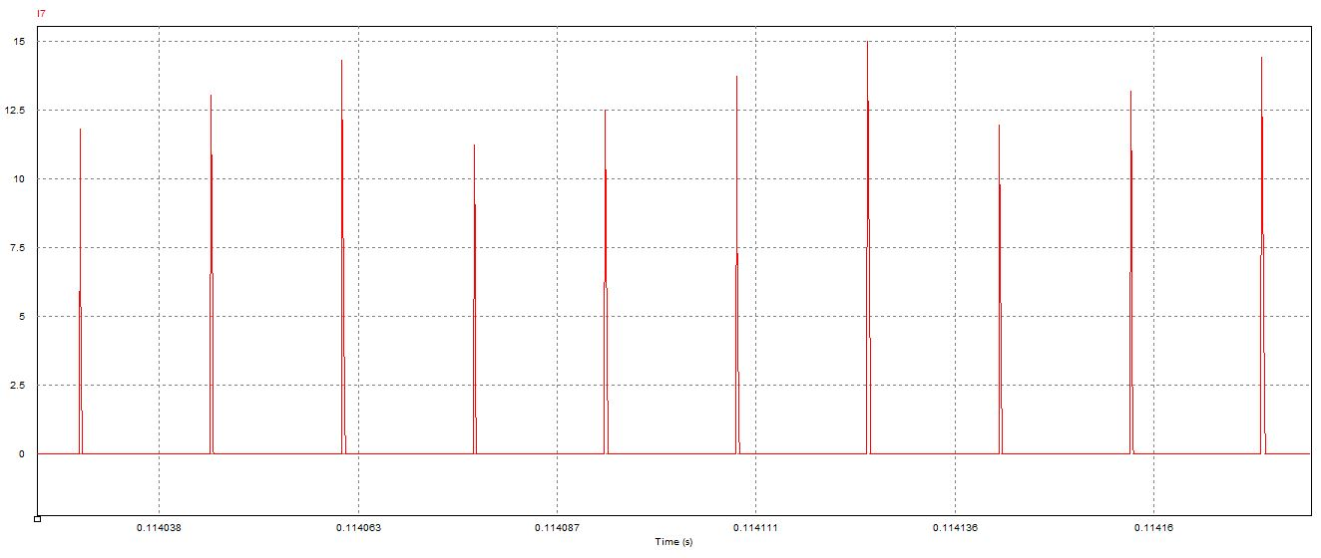

Figure 19: Snubber Diode Current Waveform

Initially, 27 A instant current is observed over the snubber diode. After that, current arrives nearly 15 V at switching instants. Therefore, two diodes are tied parallel in order to achieve 40 A capacity.

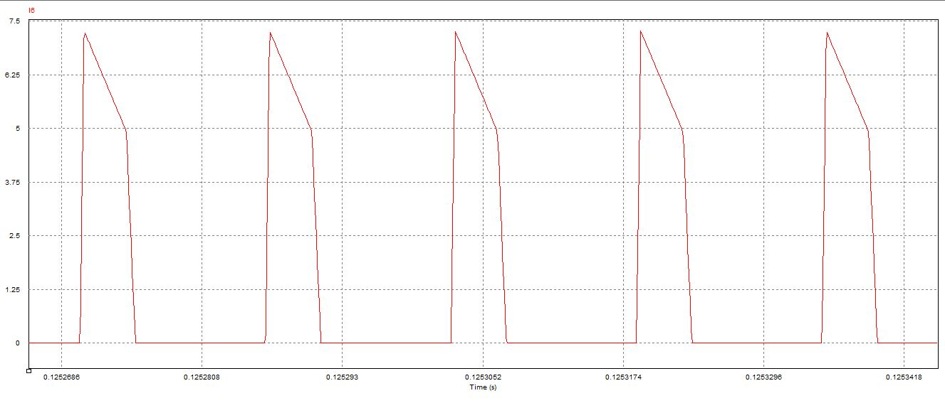

Figure 20: Output Side Schottky Current Waveform

Initially 13 A instant current is observed over the output diode. At the steady state diode current achieve 7.5 A. We selected a schottky diode which has 15 A current capacity. We selected schottky type capacitor because it keeps low voltage; that is on voltage is low for schottky diodes and output voltage affects lower by using schottky diode.

# COMPONENTS SELECTION

* Power MOSFET – IRFP260

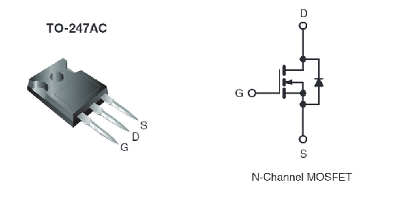

Figure 21: Selected MOSFET for he circuit

MOSFET ratings were determined according to simulation results and theoretical calculations. We saw at most 170V across the VDS and we measured at most 20A flow through MOSFET in the full load operation during simulation. Therefore, we decided to use this MOSFET in our circuit.

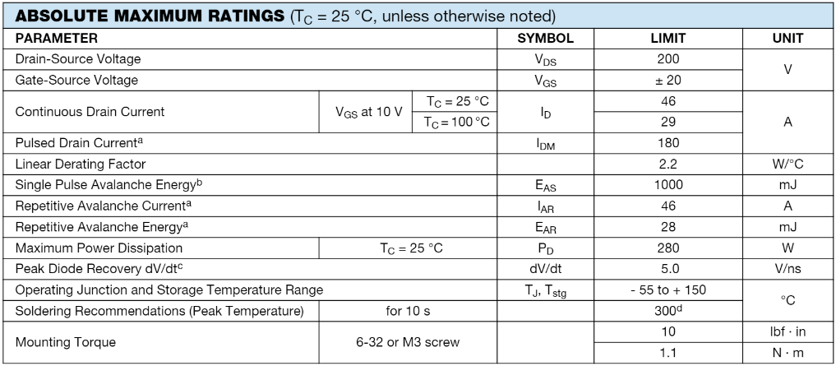

* Opto Coupler – TLP250

To isolate gate driver from the main circuit to avoid of disturbance for the pulse generator and also to avoid from possible harms of the flyback converter on the pulse generator. For this purpose, we decided to use opto coupler in our circuit. Following table illustrated the rating of the opto coupler.

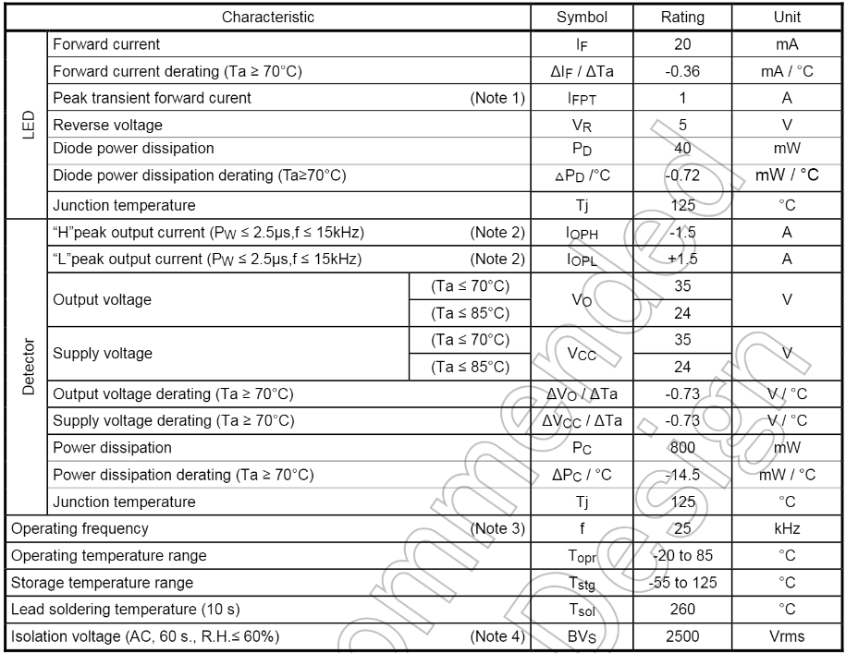

* Schottky Diode

According to measured current value in the output side of the converter, we decided current rating of the diode. Also we planned to use schottky diode to avoid from high voltage drop on diode during operation.

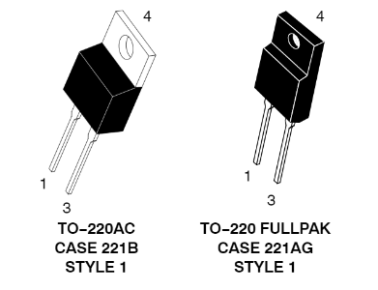

Figure 22: Selected Diode for the output side of converter.

* Output Capacitor

Output capacitor selected according to maximum voltage can be obtained at the output. So that, the maximum voltage level at the output in our circuit is equal to 48 Volts. Therefore, we decided to use 100V rating capacitor at the output.

* Snubber Diode

According to simulation results, we decided rating of the snubber diode. Inıtially, 25-30 A instant current is observed on the simulation and at most 15 A current is observed in the steady state. Two diodes are tied parallel in order to achieve 40 A current rating. Following table illustrates rating of the snubber diode.

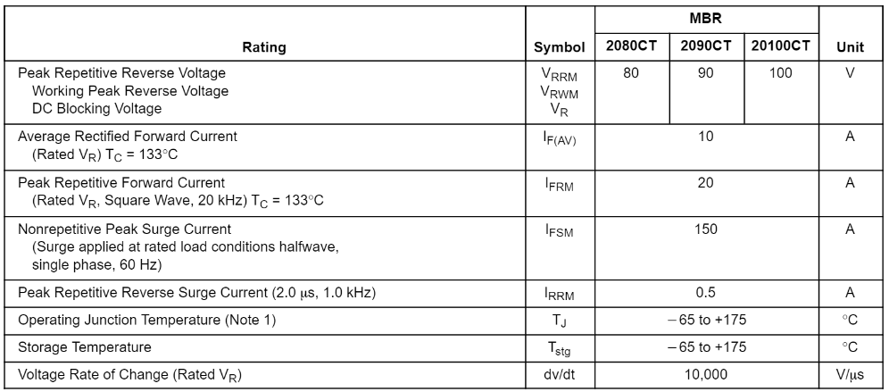

* Snubber Capacitor

10 uF, 250 V capacitor is used at the snubber. 150 V is observed on the simulation so 250 V voltage rating is selected.

* Snubber Resistor

1 kΩ, 25W aluminum resistor is selected for the snubber resistor. Nearly 18 W loss was expected through the resistor.

# TEST RESULTS

These test results are obtained for 48 V output voltage and 35 W output power.

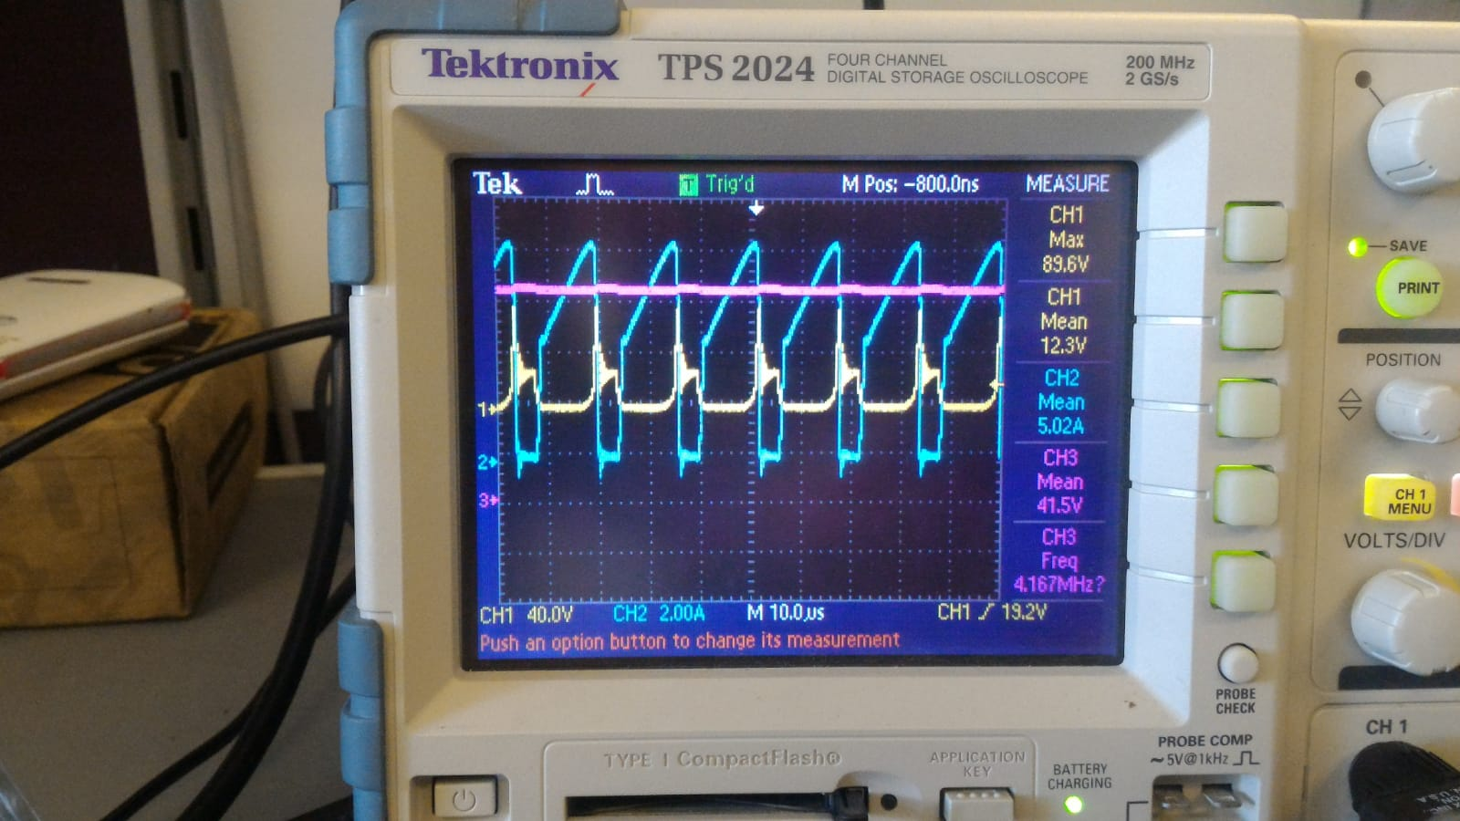

Figure 23: Input Voltage, Input Current and Output Voltage Characteristic

As shown in Figure 23, mean of input voltage is 12.3 V. However, spikes are observed at the input voltage. If input capacitors are used at the input side (if capacitors are tied parallel to the source), input voltage ripple decrease a lot; however, these capacitor burst after some time. These spikes’ frequency is equal to switching frequency. At the switch instants, some voltage is send to input side; however we did not succeed to decrease this ripple.

In addition, input current has expected waveform. It corresponds to simulations. Saturation is not observed and continuous conduction mode is observed.

Output voltage is nearly a pure DC voltage, ripple is very low. 100uF output capacitor is used at the output side.

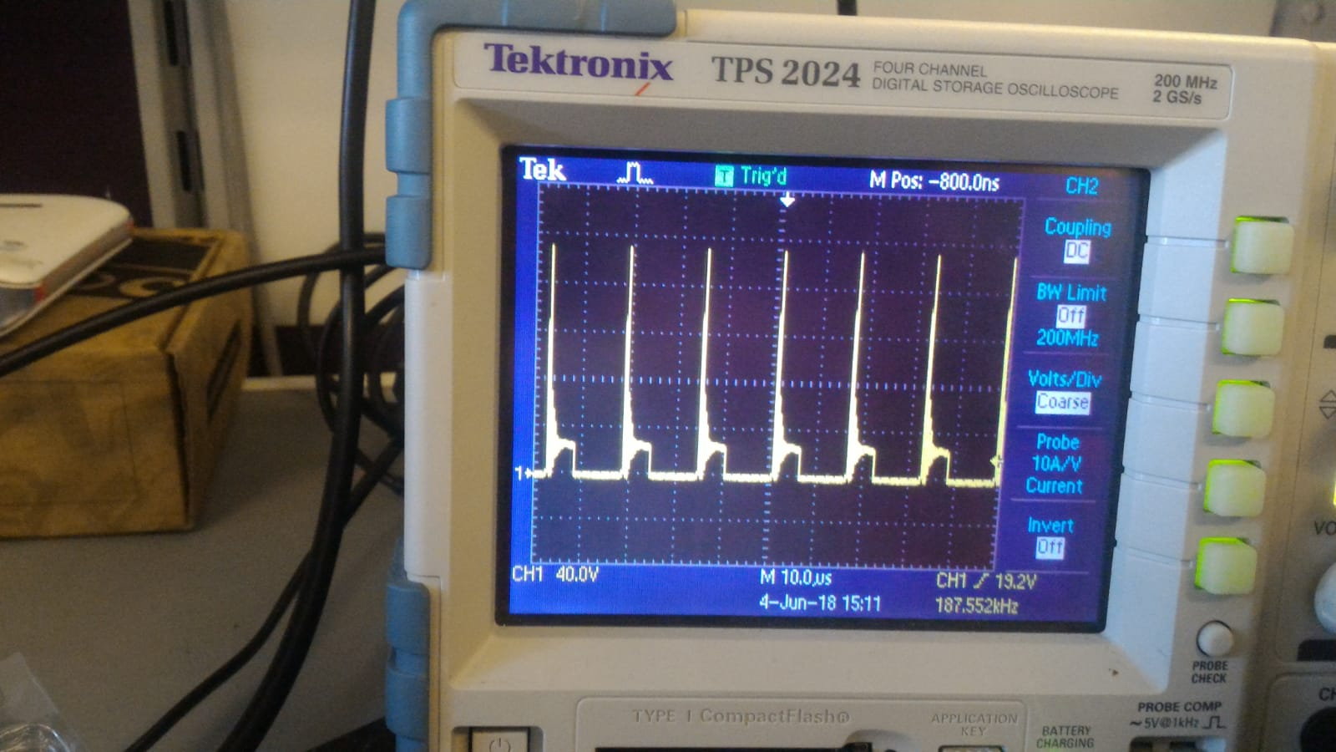

Figure 24: Drain- Source Voltage Characteristic

TLP250 optocoupler is used in order to drive the gate with isolation. When 10 Ω resistor is connected between output of the TLP250 and the gate Vds arrives nearly 200 V as shown in Figure 24. When this resistor is changed with 250 Ω, Vds decrease to nearly 120 V as shown in Figure 25. However, time constant increase so rise and fall time of the PWM increase so square wave distort. Even so we use 250 Ω resistor in order to decrease Vds voltage.

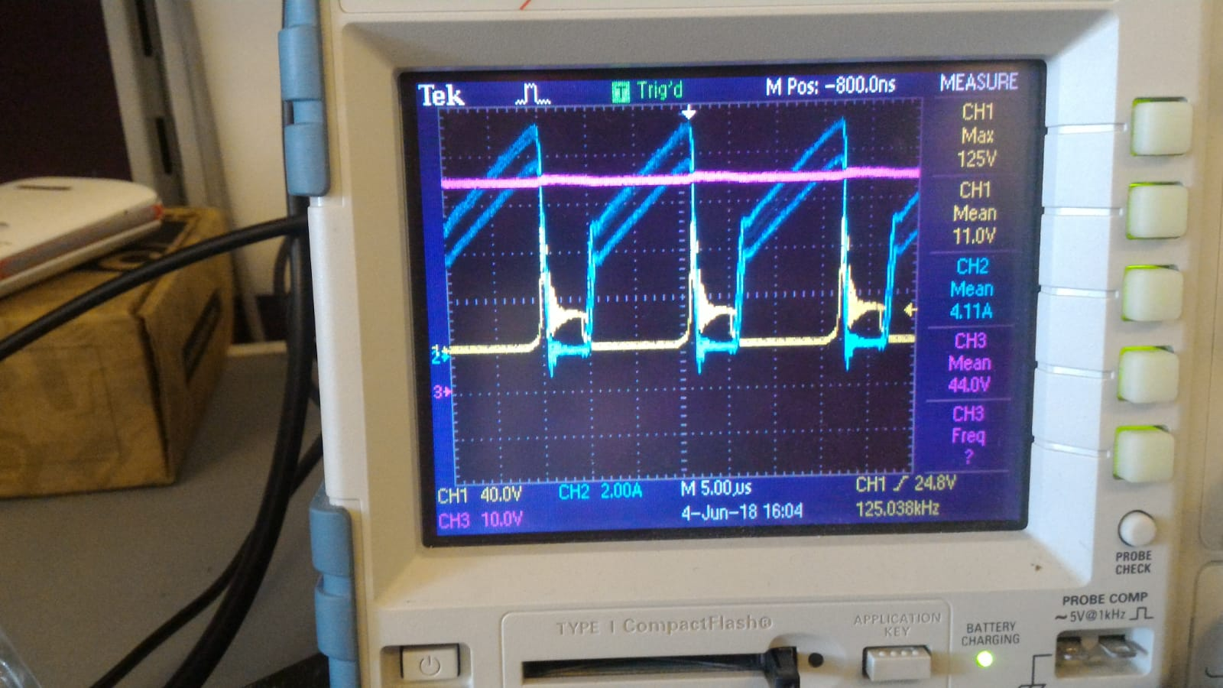

Figure 25: Drain- Source Voltage, Input Current and Output Voltage Characteristic

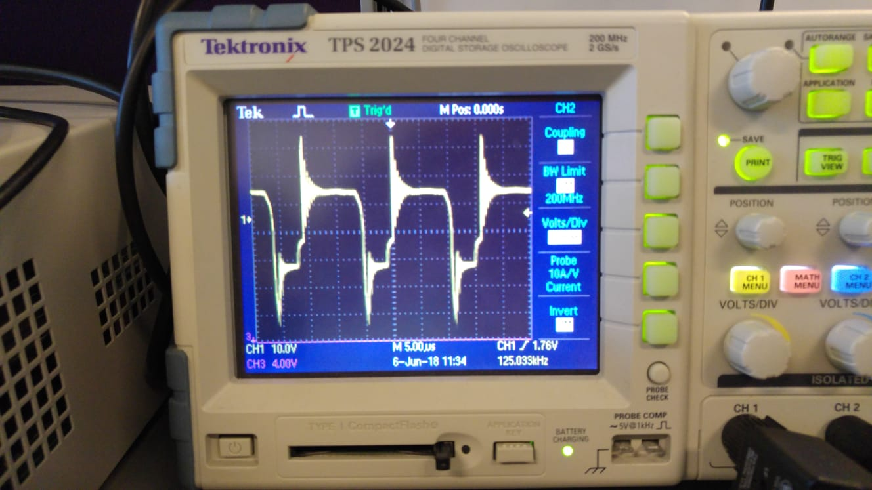

Figure 26: Transformer Voltage Waveform

Transformer voltage waveform corresponds to simulation results. There are some spikes at switching instants due to leakage inductance.

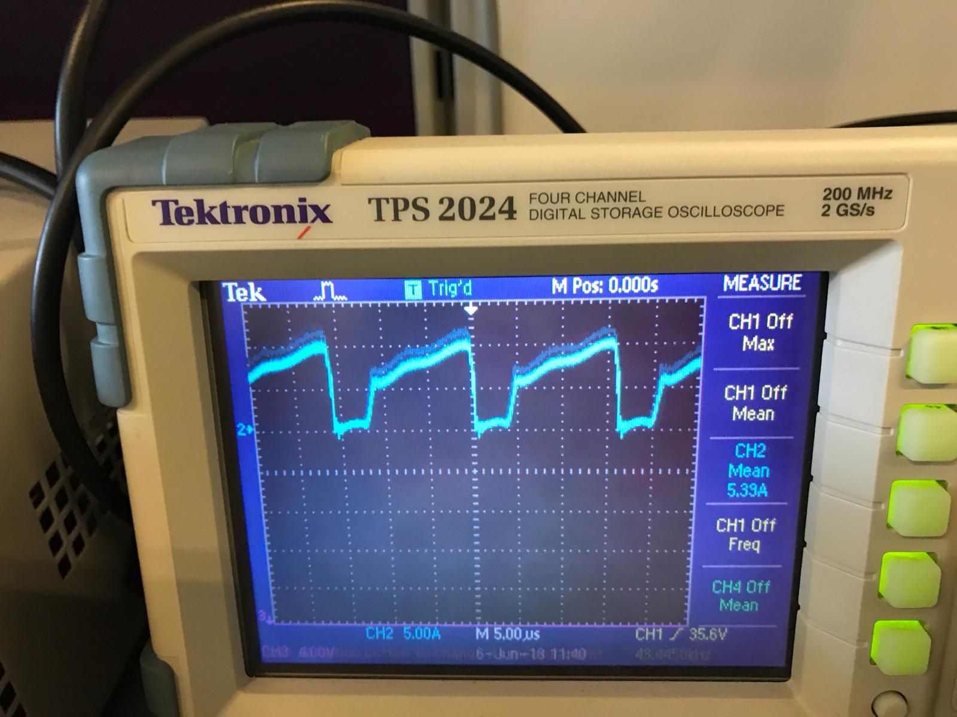

Figure 27: Transformer Current Waveform

As expected, transformer current waveform is the same as input current waveform and it corresponds to simulation results.

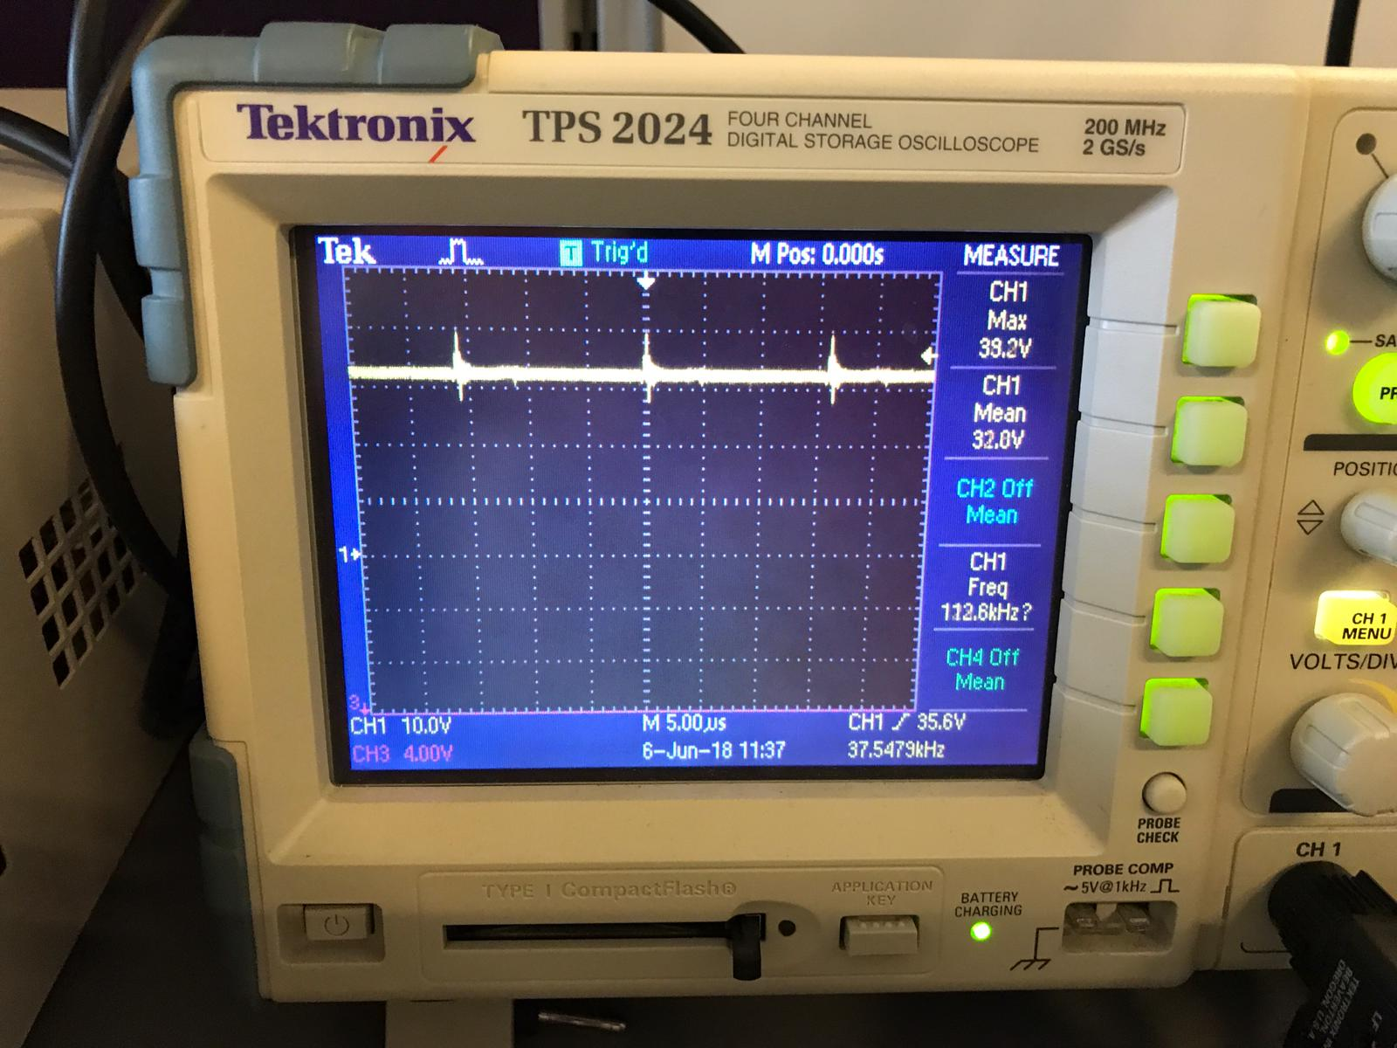

Figure 28: Snubber Voltage Waveform

As shown in Figure 28, practically, mean of the snubber voltage is 32 V and it is too low. It was nearly 150 V at the simulation. Snubber voltage is too low; therefore, heat cannot be removed through snubber resistor. Instead, transformer and MOSFET heat up so temperature of the transformer increase a lot at the full load and converter cannot work effectively at the full load.

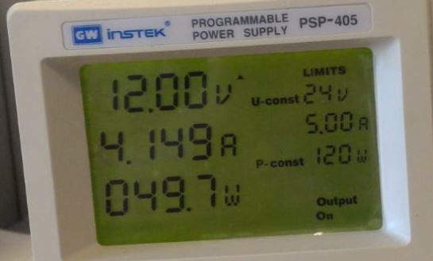

Figure 29: Voltage, Current and Power Values of the Power Supply

As shown in Figure 29, output voltage is 44 V and R load is 65 Ω. Therefore,

Pin= 49.7 W

Efficiency= 60 %

In addition, at the full load, temperature of the transformer increase a lot. Nearly 1250 C is observed and temperature of the MOSFET increase to 900 C which is not a very high temperature for the MOSFET. However, converter works successfully at the half load, high temperatures are not observed. Nearly 400C is observed for the MOSFET which was the hottest component in the circuit.

# CONCLUSION

In this project, 12 V to 48 V flyback converter is implemented. In this process, transformer design and snubber design are done, simulations are observed and appropriate components are investigated according to voltage and current ratings. Gate drive and control were some of the crucial points at this project. Initially, we investigated analog controllers which are UC3842 and UC3845. Also, LT3748 which is flyback controller was investigated and some design was implemented on the simulation. However, we tried 555 timer in our circuit and eventually, we used Arduino and optocoupler in order to drive the gate.

There are some differences between theoretical and practical results. For example, snubber resistor kept nearly 150 V on the simulation; whereas, it kept nearly 35 V practically. Therefore, temperature of the transformer increases a lot at the full load. Also, output voltage decreased from 48 V to nearly 38 V at the full load. It may be caused from the fact that we ignore the voltage drop on copper windings. Also, copper loss is another factor for the high transformer temperature.

In conclusion, we observed the importance of the component selection and cooling operations one more time. Transformer design and snubber design are the other crucial operations. Transformer should be designed carefully in order to prevent the saturation. Also, energy stored in the leakage inductance should be dissipated on snubber instead of transformer and switching component in each cycle. We observed that, frequency should be arranged with a balance of component size and switching loss. There is a trade-off and optimum frequency should be used. As mentioned in Transformer Design section, small gapped or ungapped flyback transformers are more likely to saturate; however, saturation can be avoided by increasing the size of the transformer. In small gapped or ungapped transformers, desired magnetizing inductance can be achieved by less number of turns, which means lower leakage inductance. In our transformer design, leakage inductance becomes a significant factor in the circuit and causes high amount of heat loss. Therefore, we should have preferred a transformer with smaller gap and larger cross sectional area.

# REFERENCES

[1] <https://e2echina.ti.com/cfs-file/__key/telligent-evolution-components-attachments/00-24-01-00-00-40-60-31/snubber-design.pdf>

[2] N. Mohan, T. M. Undeland, and W. P. Robbins, Power electronics: converters, applications, and design (pp. 308-310). New York: John Wiley, 1995.